**SUMMER TRAINING PROJECT REPORT**

**ON**

**LEARN HTML CSS BOOTSRAP GIT GITHUB – FOR BEGINNERS – BATCH 1**

***Submitted by:***

**MANMEET KAUR**

**1/19/FET/BCS/167**

***Under the Guidance of***

**GAURAV KUMAR DR. NITASHA SONI**

**INTERNSHIP TRAINER**  **ASSISTANT PROFESSOR**

***in partial fulfillment for the award of the degree of***

**BACHELOR OF TECHNOLOGY**

**IN**

**Computer Science & Engineering**



**Faculty of Engineering & Technology**

**MANAV RACHNA INTERNATIONAL INSTITUTE OF RESEARCH AND STUDIES, Faridabad**

**NAAC ACCREDITED ‘A’ GRADE**

**JANUARY, 2021**

**Acknowledgement**

I acknowledge the encouragement and assistance given by Mr. Gaurav Kumar for providing me the opportunity to complete my internship under his supervision and contributed in boosting my confidence and also helped me in finishing assignments on time. He gave me in-time feedback on my assignments and helped me to organize an interesting project.

I would like to acknowledge and appreciate the efforts of Dr. Nitasha Soni and Ms. Monika Garg, Training Coordinators who were available during the whole internship and provided me with the much-required information for my queries.

I would like to extend my heartfelt thanks to Dr. Tapas Kumar, HOD who provided me with the opportunity to complete my Internship with Mentorif.

Last but not the least, I would like to express my Gratitude towards Dr. Geeta Nijhawan, Associate Dean for introducing me to this great opportunity in which I have developed myself both academically and professionally.

Mannmet Kaur, 1/19/FET/BCS/167

**Declaration**

I hereby declare that this project report entitled “**LEARN HTML CSS BOOTSTRAP GIT GITHUB – FOR BEGINNERS – BATCH 1**” *by* **MANMEET KAUR (1/19/FET/BCS/167),** being submitted in partial fulfillment of the requirements for the degreeof Bachelor of Technology in **Computer Science and Engineering** under Faculty of Engineering & Technology of Manav Rachna International Institute of Research and Studies, Faridabad, during the academic year January,2021, is a bona fide record of our original work carried out under guidance and supervision of **GAURAV KUMAR, INTERNSHIP TRAINER**  and has not been presented elsewhere.

1. Manmeet Kaur, 1/19/FET/BCS/167



**Manav Rachna International Institute of Research and Studies, Faridabad**

**Faculty of Engineering & Technology**

**Department of Computer Science & Engineering**

January, 2021

**Certificate**

This is to certify that this project report entitled “**LEARN HTML CSS BOOTSTRAP GIT GITHUB – FOR BEGINNERS – BATCH 1**” *by* **MANMEET KAUR (1/19/FET/BCS/167),** submitted in partial fulfillment of the requirements for the degreeof Bachelor of Technology in **Computer Science and Engineering** under Faculty of Engineering & Technology of Manav Rachna International Institute of Research and Studies Faridabad, during the academic year January 2021, is a bona fide record of work carried out under my guidance and supervision.

**(Signature of Project Guide)**

Name of Project Guide

**DESIGNATION**

Department. of Computer Science & Engineering

Faculty of Engineering & Technology

Manav Rachna International Institute of Research and Studies, Faridabad

Dr. Tapas Kumar

Professor & Head of Department

Department. of Computer Science & Engineering (IBM)

Faculty of Engineering & Technology

Manav Rachna International Institute of Research and Studies, Faridabad

**TABLE OF CONTENTS**

**Acknowledgement i**

**Declaration ii**

**Certificate iii**

**Certificate from Industry iv**

**Table of Contents v**

**Chapters vi**

**Chapter No.** **Page No**

1. **Introduction** 
   1. Name, duration and organization of course.
   2. Goals and Objectives: What are to be achieved?

Motivation: Why this project undertaken?

Method: How was it carried out?

* 1. Overview of the technical area i.e., background technical context
  2. Overview of the report: what material will you be covering and how it is arranged in the report

1. **Integration with full stack**
   1. Technologies used
   2. Skills acquired
   3. Implementation with full stack development
2. **Real life application of the course taken**
   1. Git, Git hub
   2. HTML, CSS
   3. Bootstrap
3. **Project/Real life problems implementation using programming skill learned** 
   1. Portfolio using HTML, CSS

<html>

<head>

<title>RESUME</title>

<style>

div {

  background-color: #4d4d4d;

  color: white;

  width: 45%;

  margin-left: 935px;

  margin-right: 20px;

  padding: 5px;

  height: 96%;

  position: fixed;

}

div2 {

  background-color: #d9d9d9;

  color: black;

  width: 72%;

  margin-right: 5px;

  margin-left: 5px;

  padding-left: 10px;

  padding-right: 2px;

  height: 97.5%;

  position: fixed;

}

img {

  border-radius: 50%;

  }

</style>

</head>

<body style= "Calibri;">

<div>

<br>

<center><img src="manmeet1.jpg" height="120px" border="2px";><br><br>

<font face="HP Simplified Light" color=""><b>CONTACT</b></font>

</center>

<hr width="50%">

<center>

<img src="1.png" height=15px;> 8743871587<br>

<img src="2.png" height=15px;> mk87438715871@gmail.com<br>

<img src="3.png" height=15px;> J11/61 Rajouri Garden, New Delhi, 110027 <br>

<img src="4.png" height=15px border="white";><a href="https://www.linkedin.com/in/manmeet-kaur-514850200/"> linkedin profile </href></a>

</center>

<br><br>

<center><font face="HP Simplified Light" color=""><b>LANGUAGES KNOWN</b></font>

<hr width="50%">

<ul>

  <li>English</li>

  <li>Hindi</li>

  <li>Punjabi</li>

</ul>

</center>

<center><font face="HP Simplified Light" color=""><b>INTERESTS</b></font>

<hr width="50%">

<ul>

  <li>Basketball</li>

  <li>chess</li>

</ul>

</center>

</div>

<div2>

  <font face="HP Simplified Light" color="">

  <h1 align="center">MANMEET KAUR </h1>

</font>

<font face="HP Simplified Light" size="5"><b>CAREER OBJECTIVE</b> </font><hr width="25%" color="black" align="left">

<font size="3">

Secure a responsible career as a software designer to fully utilize my skills, while coordinating with my team to make a significant contribution to the success of the company.<br></font><br>

<font face="HP Simplified Light" size="5"><b>EDUCATION</b></font><hr width="20%" color="black" align="left">

<table border=2 cellpadding="2" cellspacing="2" >

  <tr align="center" bgcolor="#8c8c8c">

    <th>Examination</th>

    <th>Year </th>

    <th>School/University</th>

    <th>Grade</th>

  </tr>

  <tr align="center">

    <td> Semester 2 </td>

    <td> 2021</td>

    <td> MRIIRS</td>

    <td> 8.5</td>

  </tr>

  <tr align="center">

    <td> Semester 1 </td>

    <td> 2020</td>

    <td> MRIIRS</td>

    <td> 7.5</td>

  </tr>

  <tr align="center">

    <td>Class XII(CBSE)</td>

    <td>2019</td>

    <td>G.D Goenka School,dwarka</td>

    <td>80%</td>

  </tr>

  <tr align="center">

    <td>Class X(CBSE)</td>

    <td>2017</td>

    <td>Maxfort School,dwarka</td>

    <td>9.0</td>

  </tr>

</table><br>

<font face="HP Simplified Light" size="5"><b>SKILLS</b> </font><hr width="10%" color="black" align="left">

<font size="3">

<ul>

          <li>Proficiency in C++, C, Java, HTML, CSS, python.</li>

          <li>Skilled at effective communication and collaboration with team.</li>

          <li>Skilled at critical thinking and logical reasoning.</li>

          <li>Skilled in out of the box implementation and problem solving.</li>

</ul>

</font>

<font face="HP Simplified Light" size="5"><b>TECHNICAL TRAINING / INTERNSHIP </b></font><hr width="60%" color="black" align="left">

<font size="3">

  <ul>

          <li>Attended workshop on Machine Learning by Cognixia</li>

          <li>Attended workshop on Implementation of Data Structures and Algorithms.</li>

          <li>Dr. Vikram Sarabhai Memorial Lecture on 22nd November by Padma Shri M. Chandra Dathan.</li>

          <li>Course "An introduction to interactive programming in python" from Coursera</li>

          <li>Course "Data science maths skills" from Coursera </li>

          <li>Course "Introduction to ralational Database and SQL" from Coursera </li>

    </ul>

</font>

</div2>

</body>

</html>

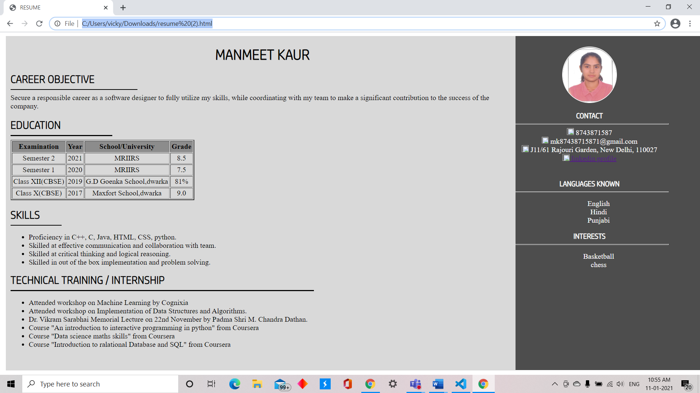

4.2 Portfolio using Bootstrap